**LAB # 4**

**Lab Task**

**Output:**

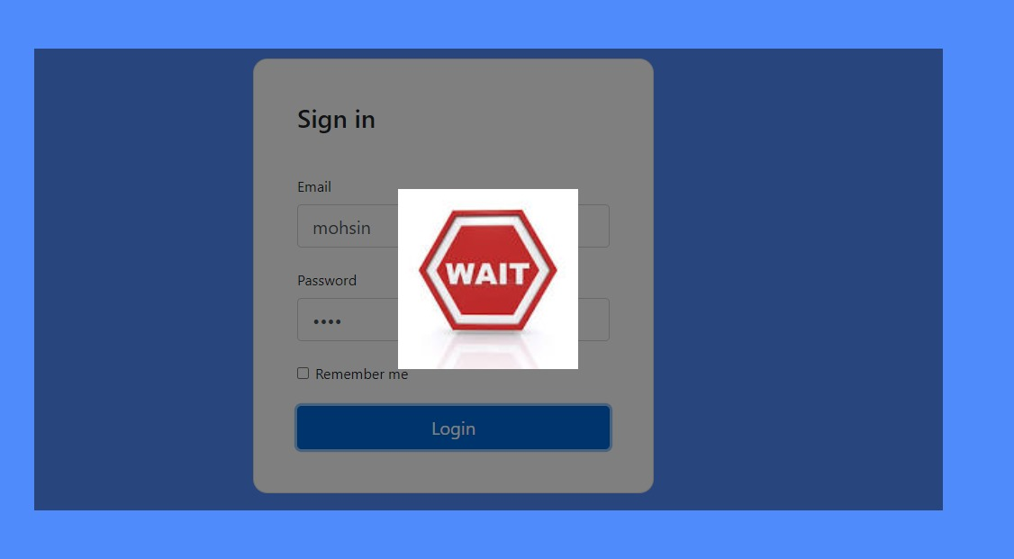

## Home Task

